Sprint 1 - Endurance Design Document

October 30, 2024

This document contains instructions and examples which are for the benefit of the person writing the document. All text in RED should be removed and replaced with information pertinent to your project.
Text in the finalized document must be BLACK.
This is the System Design Document (SDD) and will include sections detailing system flow, algorithms, staffing plan, software/hardware, and Test Plan
You must complete all sections of this document.
Where required by the Sprint Checklist you must embed images of some artifacts in this SDD
To regenerate the TOC in Word, select all (CTL-A) and press F9.
Table of Contents
1. Executive Summary 3
1.1 Project Overview 3
1.2 Purpose and Scope of this Specification 3
2. Product/Service Description 3
2.1 Product Context 3
2.2 User Characteristics 3
2.3 Assumptions 3
2.4 Constraints 3
2.5 Dependencies 4
3. Requirements 4
3.1 Functional Requirements 5
3.2 Security 5
3.2.1 Protection 5
3.2.2 Authorization and Authentication 6
3.3 Portability 6
4. Requirements Confirmation/Stakeholder sign-off 6
5. System Design 6
5.1 Algorithm 6
5.2 System Flow 6
5.3 Software 6
5.4 Hardware 6
5.5 Test Plan 7
5.6 Task List/Gantt Chart 7
5.7 Staffing Plan 7

Executive Summary

Project Overview
The project is to make the Sphero robot move in a box shape marked on the floor.

Purpose and Scope of this Specification
Describe the purpose of this specification and its intended audience. Include a description of what is within the scope what is outside of the scope of these specifications. For example:
Specifically to get a sense of how to work with the Sphero robot.
In scope
- Better knowledge of the Sphero robot and its controls
Out of Scope
- How to code without block code.

Product/Service Description
The main factor that effect the requirements is availability of the room that has the box path.

Product Context
This product is self-contained with the use of a single Sphero robot.

User Characteristics
Students that want to better understand coding in a simple and physical way.

Assumptions
The testers and users doing this project are new to the Sphero Robot code and are learning how to use it.

Constraints
The only aspect that has the design aspect in this project is building the block code to accurately follow the path.

Dependencies
Dependences of the project is the batter of the robot, needing to be charged constantly to use it and little bumps on the floor or tape getting in the way of the robot and shirting the angle it was going.

Requirements
Requirements
- Follow line path accurately
- Show picture evidence of sensors and code
- Video of Robot use

Functional Requirements

Req# | Requirement | Comments | Priority | Date Rvwd | SME Reviewed / Approved
ENDUR 1 | Follow path |  | 1 | 10/30/24 | 10/30/24
ENDUR 2 | video |  | 2 | 10/30/24 | 10/30/24
ENDUR 3 | Sensor data and code |  | 3 | 10/30/24 | 10/30/24
ENDUR_XX

Security

Protection
Protecting the code and misuse of the robot with keeping the project to a single room and secure on a repository.

Authorization and Authentication
The Authentication facts would be the video and picture evidence of the work.

Portability
Portability is not a requirement with it being confined to Class HH208

Requirements Confirmation/Stakeholder sign-off

Meeting Date | Attendees (name and role) | Comments
10/30/24 | Travis Asante Videographer | Signed off
10/30/24 | Josh Castro Coder | Signed off

System Design
The project was tested and coded by everyone with taking measurement and angles to complete the project.

Algorithm
The code will have a basic path of starting at bottom left corner, then correcting the forward angle and turning to return to its original place.

System Flow
https://drive.google.com/file/d/1Ju9-7_zTtdsrL2OKlLS-oVW6RiGp_2q5/view?usp=sharing

Software
Block code was use to complete the Project.

Hardware
Done by Phone with the Sphero App.

Test Plan

Reason for Test Case | Test Date | Expected Output | Observed Output | Staff Name | Pass/Fail
Angle correction | 10/30/24 | Fix the angle issue | Angle Effected the accuracy | Michael Y  Travis A  Josh C | fail
Distance correction | 10/30/24 | Get correct distance | Distance was slightly off | Michael Y  Travis A  Josh C | fail
Confirmation run | 10/30/24 | Confirm the completion | Ran great | Michael Y  Travis A  Josh C | Pass

Task List/Gantt Chart
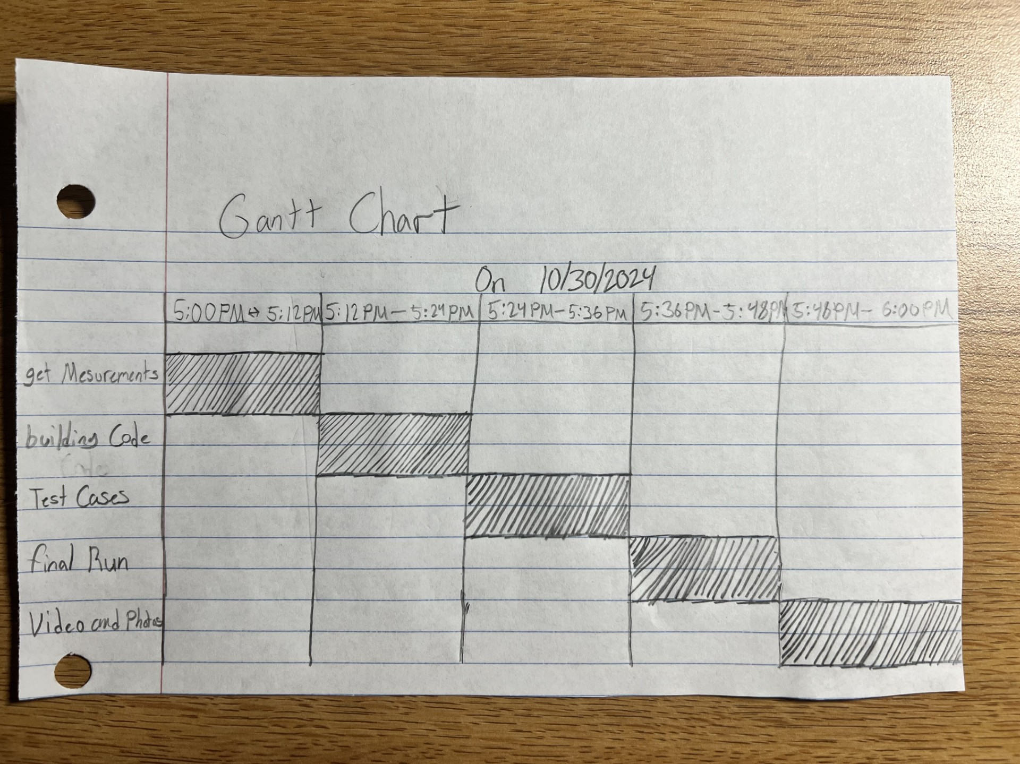
Could not figure it out on Excel.

Staffing Plan

Name | Role | Responsibility | Reports To
Michael Yax | Data gatherer | SDD doc | self
Travis Asante | Photographer | Video of the final test run | Michael Y
Josh Castro | Coder/debugger | Doing the block code and sensor data photo. | Michael Y

